**Data storytelling and visualization using Power BI**

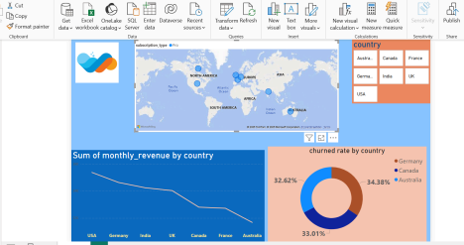

**Link–** dashboard

1 / Data exploration and cleaning—

a) Duplicate value search —

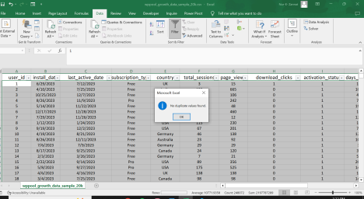b) Missing value / inconciestencies —

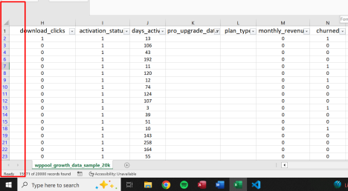C ) summary dataset

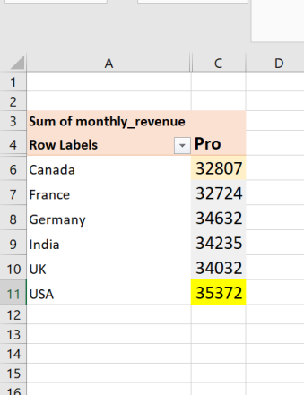2 / User engagement analysis —--

a) Avg number of session —-

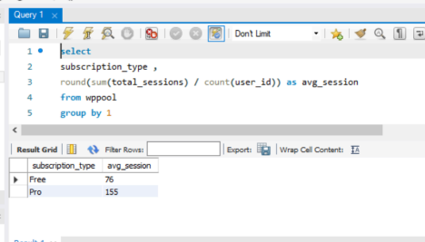b) Top 5 most active users based on total sessions —-

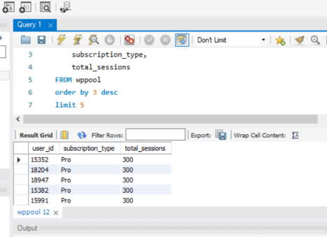

c) Top 5 country based on engagement —-----

Code —

select

country ,

sum(page_views) total_page_view,

sum(days_active) total_days_active,

sum(monthly_revenue) total_monthly_revenue,

sum(total_sessions) total_sessions

from wppool

group by 1

order by 5 desc

limit 5

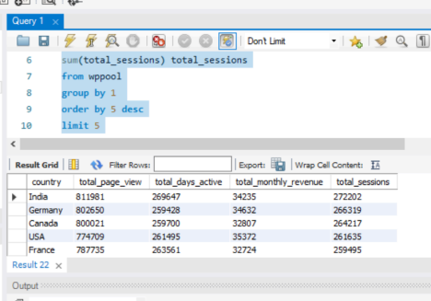

Explanation–

Here , I wanted to identify countries where total session time is high, but revenue contribution is low.

If we get this data, we can analyze the issue and share it with the business development team to find solutions and take necessary actions.

Churn analysis —-

a) Overall churn rate

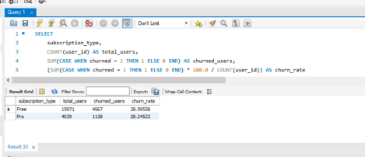

Revenue and upgrade trends —

a) Code —-

SELECT

country,

count(pro_upgrade_date ) ,

(count(pro_upgrade_date) * 100 / sum(user_id)) AS

free_to_pro_percentage

FROM wppool

GROUP BY country

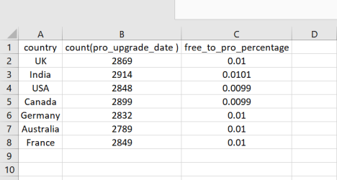free to pro

b) Total monthly revenue from pro users –

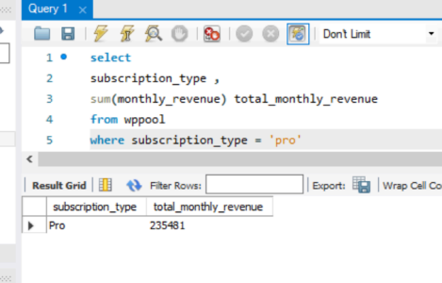c) Pro plan ( contributes the most revenue )

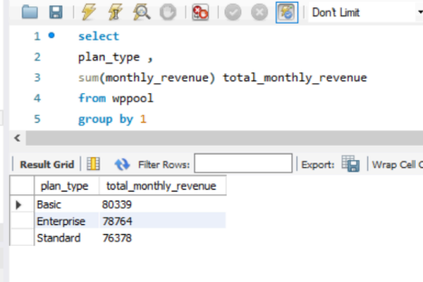d) How long it takes for free users to upgrade

Code —-

select

country ,

total_sessions ,

page_views ,

datediff(new_last_active_date , new_install_date ) as days_need_to_upgrade

from wppool

WHERE pro_upgrade_date IS NOT NULL

AND pro_upgrade_date <> ''

order by 4 desc

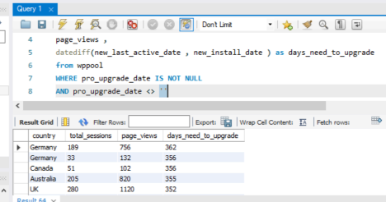pro upgrade data